**[Linux下MySQL 5.5/5.6的修改字符集编码为UTF8（彻底解决中文乱码问题）](http://www.ha97.com/5359.html" \o "Permalink to （原创）Linux下MySQL 5.5/5.6的修改字符集编码为UTF8（彻底解决中文乱码问题）)**

一、登录MySQL查看用SHOW VARIABLES LIKE ‘character%’;下字符集，显示如下：  
  
+--------------------------+----------------------------+  
| Variable_name | Value |  
+--------------------------+----------------------------+  
| character_set_client | utf8 |  
| character_set_connection | utf8 |  
| character_set_database | latin1 |  
| character_set_filesystem | binary |  
| character_set_results | utf8 |  
| character_set_server | latin1 |  
| character_set_system | utf8 |  
| character_sets_dir | /usr/share/mysql/charsets/ |  
+--------------------------+----------------------------+  
  
character_set_database和character_set_server的默认字符集还是latin1。

二、最简单的完美修改方法，修改mysql的[my.cnf](http://www.ha97.com/tag/my-cnf)文件中的字符集键值（**注意配置的字段细节**）：  
  
1、在[client]字段里加入default-character-set=utf8，如下：  
  
[client]  
port = 3306  
socket = /var/lib/mysql/mysql.sock  
default-character-set=utf8  
  
2、在[mysqld]字段里加入character-set-[server](http://www.ha97.com/tag/server)=utf8，如下：  
  
[mysqld]  
port = 3306  
socket = /var/lib/mysql/mysql.sock  
character-set-server=utf8  
  
3、在[mysql]字段里加入default-character-set=utf8，如下：  
  
[mysql]  
no-auto-rehash  
default-character-set=utf8  
  
修改完成后，service mysql restart重启mysql服务就生效。注意：[mysqld]字段与[mysql]字段是有区别的。这点在网上没人反馈过。

使用SHOW VARIABLES LIKE ‘character%’;查看，发现数据库编码全已改成utf8。  
  
+--------------------------+----------------------------+  
| Variable_name | Value |  
+--------------------------+----------------------------+  
| character_set_client | utf8 |  
| character_set_connection | utf8 |  
| character_set_database | utf8 |  
| character_set_filesystem | binary |  
| character_set_results | utf8 |  
| character_set_server | utf8 |  
| character_set_system | utf8 |  
| character_sets_dir | /usr/share/mysql/charsets/ |  
+--------------------------+----------------------------+  
  
[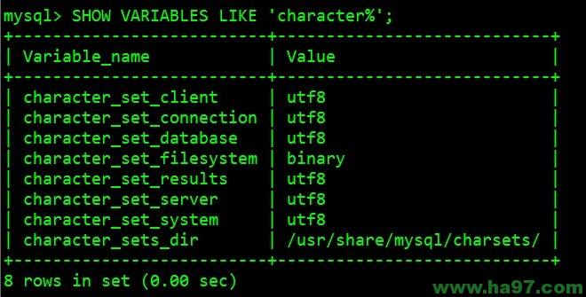](http://www.ha97.com/wp-content/uploads/2013/01/mysql-utf8.jpg)  
4、如果上面的都修改了还乱码，那剩下问题就一定在connection连接层上。解决方法是在发送查询前执行一下下面这句（直接写在SQL文件的最前面）：  
SET NAMES 'utf8';

它相当于下面的三句指令：  
  
SET character_set_client = utf8;  
SET character_set_results = utf8;  
SET character_set_connection = utf8;  
  
[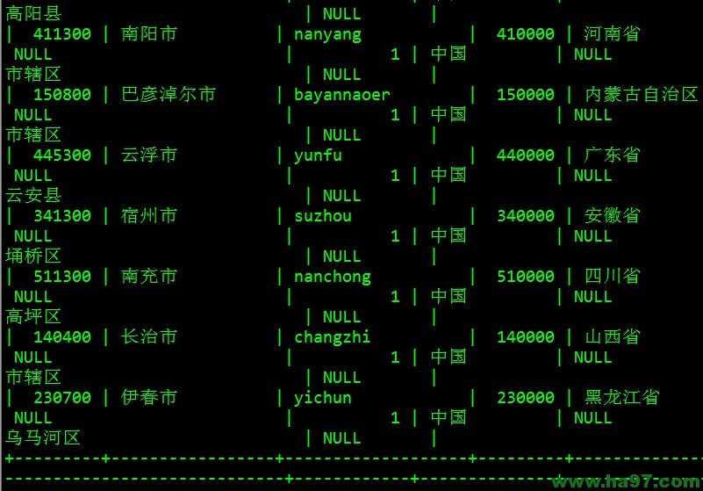](http://www.ha97.com/wp-content/uploads/2013/01/mysql-t_area.jpg)  
网上很多其他方法不能彻底解决这个问题，这个可以完美解决！